Basler Standard Light Flat Dome-200x200-x#
Basler Standard Flat Dome Lights can be used in various applications for bright field lighting of slightly objects.
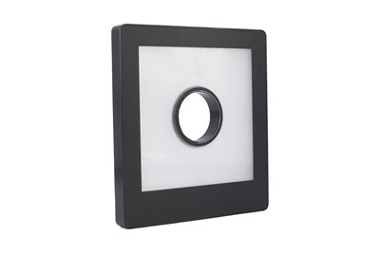
Key Features#
- Internal LED controller with 2 operating modes
- Compatible with Basler SLP Strobe Controller
- Preconfigured hardware components
- Various sizes and LED colors
General Specifications#
 |  | Basler Standard Light Flat Dome-200x200-White
Order Number |  | 2200000732
LED Color |  | White
Luminous Area |  | 200 x 200 mm
Lens Hole (diameter) |  | 45 mm
Recommended Light Working Distance |  | 100–500 mm
Conformity
LED Specifications#
 | Flat Dome Light Series 200x200-x
Luminous Power of  White LEDs (lumen) | 2090
Radiant Power of  Red LEDs (mW) | 6150
Radiant Power of  IR LEDs (mW) | 2960
Electrical Specifications#
 | Flat Dome Light Series 200x200-x
Required Power for Voltage Control Mode | 24 VDC ± 10 %,  22 W
Required Current for Current Control Mode | Red, White, and Blue: 1200 mA  Infrared: 1500 mA
Recommended max. LED Current for Strobe Mode  (50 % Duty Cycle, 100 ms Pulses) | Red, White, and Blue: 2400 mA  Infrared: Must never be used.
Recommended max. LED Current for Strobe Mode  (25 % Duty Cycle, 20 ms Pulses) | Red, White, and Blue: 3600 mA  Infrared: Must never be used.
Recommended max. LED Current for Strobe Mode  (10 % Duty Cycle, 5 ms Pulses) | Red, White, and Blue: 4800 mA  Infrared: 3000 mA
Infrared only: Recommended max. LED Current for Strobe Mode  (1 % Duty Cycle, 100 µs Pulses) | 4500 mA
Recommended min. Flash Time in Strobe Mode | 100 µs
Mechanical Specifications#
 | Flat Dome Light Series 200x200-x
Dimensions  (H x W x D) | 240 x 230 x 12 mm
Weight | 1150 g
Material | Black anodized aluminum housing with PMMA light cover
Connector | M8 socket, 4-pin male connector

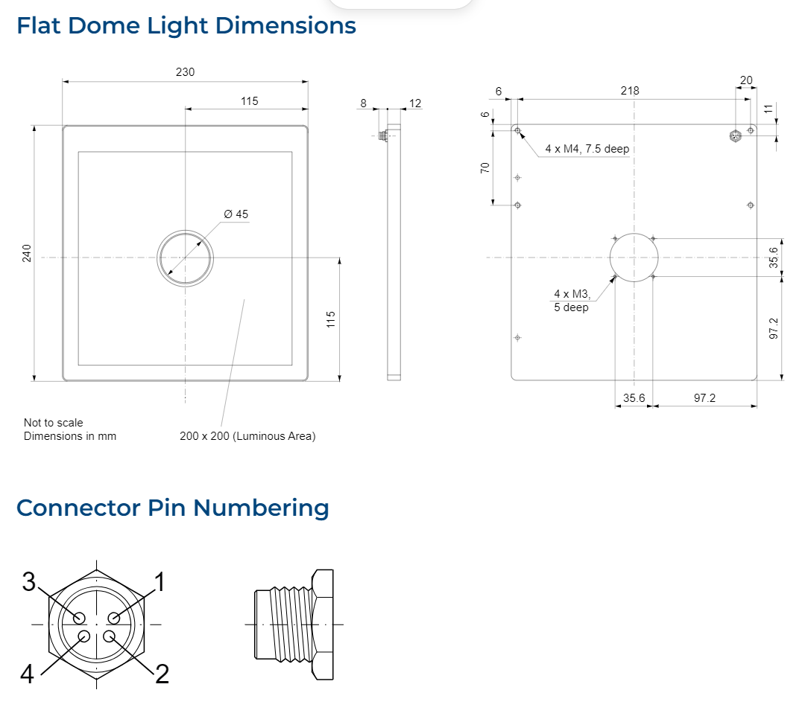
Please contact OEM Automatic for technical assistance.
Email: vision@oem.co.uk
Telephone: 01162849900

